1. CICD flow: GIT > Jenkins > Maven >Artifactory >Testing > Deployment
2. Trunk based Development
3. How long branch needs to live? Answer: few hours (ideally, else merge conflict)
4. Deployment (Canary, Greenblue and rolling update (1 by 1, 1 at a time))
5. Agile 4 pilar

* Individuals and interactions over processes and tools.
* Working software over comprehensive documentation.
* Customer collaboration over contract negotiation.
* Responding to change over following a plan.

1. TDD, BDD, FDD
2. How to check efficiency of Devops

* Mean-Time-to-Change (MTTC)
* Mean-Time-to-Recovery (MTTR)
* Mean-time-to-incident (MTTI)
* Frequency of release

1. Devops Phase: Plan code build test release deploy operate monitor
2. Devops goal: time to market.

SRE Principle:

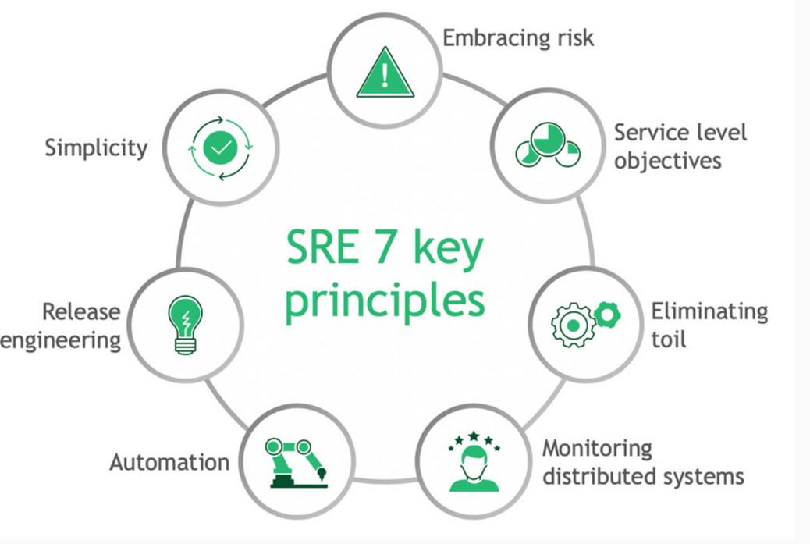

CICD principle:

